Palestine & Israel conflict Before 7th October

Table of Contents:

* Data sources
* Analysis context
* Data cleaning documentation.
* Answering the Questions
* Conclusions
* Sources

Data Sources:

The data used in this analysis is **pre-collected** using [**ACLED**](https://acleddata.com/data-export-tool/)& [**UNCHR**](https://data.humdata.org/dataset/unhcr-population-data-for-pse)so the data behind this analysis is trustable and not biased by any way.

The analysis doesn’t cover **any event after 6th** **of October** **2023** in fact the Palestinian displacement data is limited until 2022 which leads to more **Bias-clear Analysis** because it didn’t get affected by the current news trends, thought this **ISN’T** Historical analysis so we won’t analyze any data before the 2000th.

Here we are going to use 2 different data sets to create wider analysis which are:

* **Palestinian displacement** data and the destinations they went for by ([**UNCHR**](https://data.humdata.org/dataset/unhcr-population-data-for-pse)).
* **Palestine Israel battles** history between October 2020 and October 2023-10-6.

Analysis Context:

In this analysis we will see what the data and the **data** **ONLY** says about the ‘Palestine & Israel conflict’ by analyzing the **Palestinian displacement** & **The battles data** and answering some **questions** so let’s start:

1. How does the Palestinian refugee change per year and what battles were them associated with.
2. How does the Palestinian refugees spread around the countries since 2001.
3. What events are the most frequent by Israel & Palestine.
4. How much did civilian attacks happen from Israel & Palestine.
5. Battles timeline between Israel & Palestine each month since 2020.
6. How much kills happened from Palestine to Israel & vice versa each month since 2020.

Data Cleaning Documentation:

I tried my best to check accuracy and unbiasedness in the data, so I removed the columns those contained wrong values or useless data, so I didn’t use prebuild **civilian** **targeting** instead I built my own **civilian** **targeting column** based on the actors of the event columns.

Also, I contacted all of the actors’ columns for easier readability and less total columns and removed some location related columns because I won’t use them anyway.

**Important Note:** If you want to check of the data accuracy you can check the raw data folder.

Answering the Questions:

Answer 1

We can see in the chart below **non-linear** refugees’ trend which suddenly drop on **2008** by **-350%** and after searching from multiple sources we can found that **Gaza war** happened in this year also we can find other peak on **2002** which was the **Battle of Jenin.**

in total there was about **4 million Palestinian** refugees happened since **2000** Which is **about 80%** of current Palestinian population with about **100K Refugees / Year** since 2001.

After some investigation I found that after Gaza war the **UN** and the **neighbor countries** started to realize what happens in Palestine, so the **aids increased** significantly making the life a bit better.

Answer 2

Most of the **Palestinian refugees** went to some neighbor countries especially **Saudi Arabia, Egypt & Iraq** then the rest of the refugees spread around the world especially **Canda, France & most of North Amerika.**

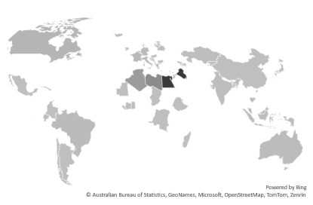

Palestinian Refugee Countries

Answer 3

We can find that the ‘Strategic attacks’ are the most common event by and Israel which includes looting, displacement etc also **98.5%** of these attacks are done by **Israel** and **Palestine** has **1.5% of the** Strategic attacks count**.**

Also we can find that **protests** are more common from Israel with **65%** of them where Palestine has **35%** of the protests count.

**Riots** are the most common by **Palestine** with **65%** of the Riots.

Answer 4

In the chart below we can find that **Israel** did ‘Civilian targeted attacks’ with **64 Times** more than **Palestine** from **2020/10** until **2023/10/6** with **7,000** attacks by Israel and **150** attacks on the other side

Where we can find that ‘Not Civilian only targeted attacks’ are commoner from Palestine with **470** attacks also we can find that the ‘Non-Civilian Targeting’ are commoner from Palestine with **9,000** and **7,000** non-civilian targeted attacks from Palestine.

Answer 5

We can find that the largest peak of battles between Israel and Palestine in the last **3 Years** happened in May 2021 was because of a **Shaikh Al-Jarah** settlement also there was a smaller one on October 2022 due some fire shooting between Palestinians trying to retrieve settlement then Israel started attacking some cities like.

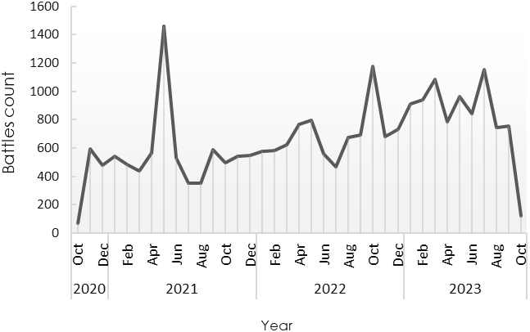

Israelian Palestinian Battles Count Last **3** Years

Shaikh Al-Jarah Settlement

Answer 6:

In most months we can find that the deaths are really low about **5~10** in **average** and it varies who has the most deaths sometimes Israel or Palestine but in the months with many battles most of the deaths was from Palestine in fact in May 2021 there was **222** **Deaths** from **Palestine** and **51** from **Israel** also after June 2022 most deaths was from Palestine with **> 20** deaths / month.

Conclusions:

**Remainder**: this data was collected by nonbiased organizations like the **UN** and the **ACLED** also all the data was collected **before** 7th of October 2023 to get out of any fake news or biased data.

So, you decide after all of what you saw from those charts those **deaths**, **refugees**, **civilian targeted battles** & **displacements** who do you think are the **‘Bad Ones’.**

Sources:

*The sources are for explaining the trends in the charts (these sources don’t affect the data shown in the charts) .

Battle of Jenin: <https://en.wikipedia.org/wiki/Battle_of_Jenin_(2002)>

Gaza war: [https://en.wikipedia.org/wiki/Gaza_War_(2008%E2%80%932009)](https://en.wikipedia.org/wiki/Gaza_War_(2008%E2%80%932009)a)

Shaikh Al Jarrah settlement: https://www.aljazeera.com/news/2021/5/1/what-is-happening-in-occupied-east-jerusalems-sheikh-jarrah